1. MAN VS COMPUTER
2. Create a new function named getComputerChoice.Write the code so that getComputerChoice will randomly return one of the following string values: “rock”, “paper” or “scissors”. Hint: The Math.random method returns a random number that’s greater than or equal to 0 and less than 1. Think about how you can use this to conditionally return one of the multiple choices.
3. Create a new function named getHumanChoice. Write the code so that getHumanChoice will return one of the valid choices depending on what the user inputs. **Hint**: Use the [prompt](https://developer.mozilla.org/en-US/docs/Web/API/Window/prompt) method to get the user’s input. Test what your function returns by using console.log.
4. Create two new variables named humanScore and computerScore in the global scope.
5. Initialize those variables with the value of 0.
6. Create a new function named playRound.
7. Define two parameters for playRound: humanChoice and computerChoice. Use these two parameters to take the human and computer choices as arguments.
8. Make your function’s humanChoice parameter case-insensitive so that players can input “rock”, “ROCK”, “RocK”, or other variations.
9. Write the code for your playRound function to console.log a string value representing the round winner, such as: “You lose! Paper beats Rock”.
10. Increment the humanScore or computerScore variable based on the round winner.
11. 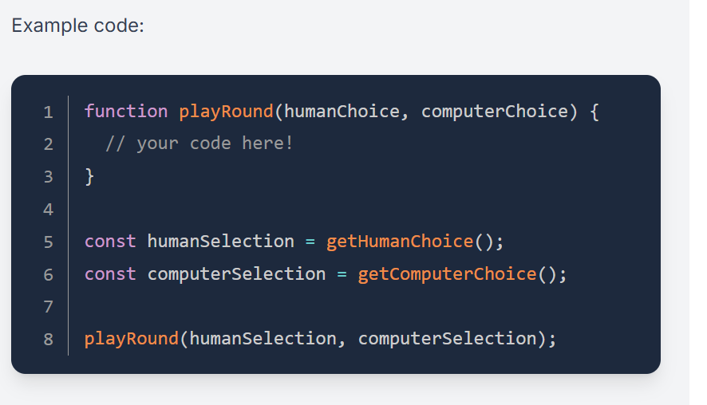
12. Create a new function named playGame.
13. Move your playRound function and score variables so that they’re declared inside of the new playGame function
14. Play 5 rounds by calling playRound 5 times.
15. Hint: When you assign a function call to a variable, the return value of that function is assigned to the variable. Accessing the variable afterward will only provide the assigned value; it doesn’t recall the function. You need to recall the choice functions to get new choices for each round.
16. Re-work your previous functions or create more helper functions if necessary. Specifically, you may want to change the return values to something more useful.
17. If you already know about loops, you can use them. If not, don’t worry! Loops will be covered in the next lesson.